INSTRUCTIONS FOR STUDENTS
  - Three steps to install and use Solstice Client on your PC laptop

Step 1
Type the IP address that is listed on the big screen in your Internet browser and click ENTER (Note: The following IP address is just an example. Use the one that show up in your classroom. Each classroom has its own IP address.)
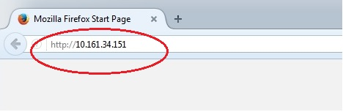
Click “Get the app & connect” and download the app.
If you are using a smart phone, go to the app store for your device, to download the Solstice Client app.
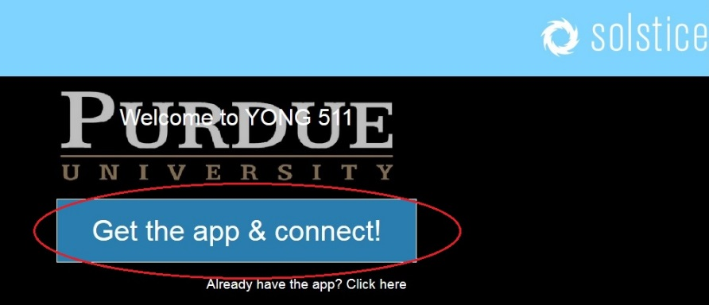
Install the app, then you will have a Solstice Client shortcut on your desktop. Click on it.
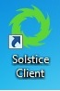

Step 2
Type the IP address again in the white box. Please do not type “http://” this time. Click Go.
Type the four digit key that shows up on the big screen. The key changes each time after you exit the Solstice platform.

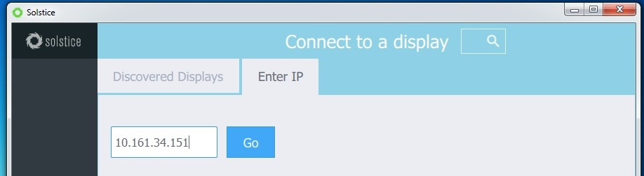
This is just an example. Please use the IP address that shows up on the big screen in your classroom

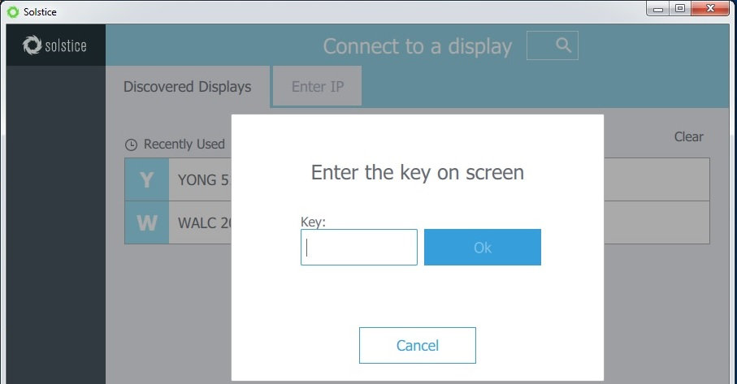
Type the four digit key here
Solstice remembers your classroom. Choose the classroom from this list when you use Solstice again.
Note: the Solstice platform will remember the IP address once you use Solstice in your classroom. You don’t need to type the IP address next time when you use it in this classroom. Click the name of the classroom from the “Discovered Displays” list, then enter the key on the big screen.

Step 3
This is the window that you will see after you connect to Solstice:
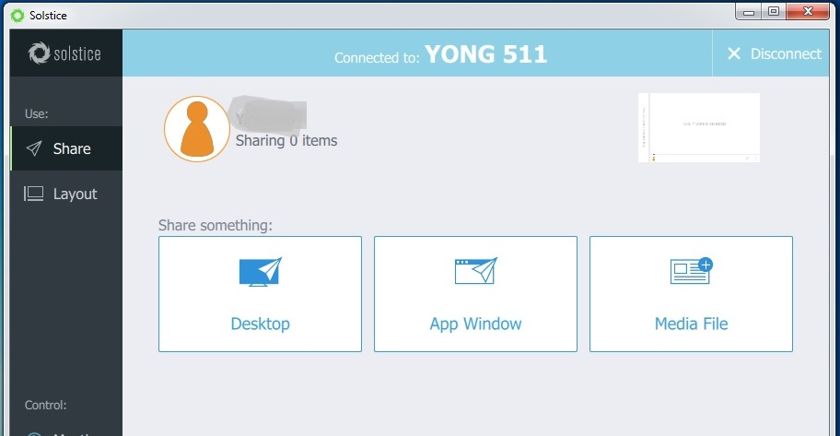
Click here to share image, video, Word document, etc.
Click here to share an app, such as PPT
Click here to share the whole desktop of your laptop
This will be the name of your classroom
Your name will show up here

Note: Only ten devices can connect to Solstice at the same time in your classroom. Please make sure you follow your instructor’s guidance before you try to connect to the Solstice Pod.

